CONCLUSIONS
- Interface wiggles
  - Are inversely proportional to the number of acquisition points – when using less acquisition points, the wiggles are “under-sampled”, meaning that they are less visible. The wiggles are always there, they are just not necessarily fully reconstructed.
  - Are directly proportional to the filtering window size (strong correlation) – this is simply because the filtering removes the high frequency parts of the echo – meaning the wiggles.
  - Are directly proportional to the filtering window ESP (very moderate correlation) – same as in the last argument.
  - Does not appear at all if the interface region does not contain signal (see 562-563 tests) – lower signal → lower wiggles of the signal.

- Interface wiggles – source
  - Error function – see internet
  - Instead of performing a regular SPA integral we multiply 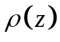 with an exponent that has phase discontinuity along the interface region. This function is actually some kind of an error function – erf – with a complex exponent. This function sends wiggles from its location to the right / left. In “conventional” SPA, having a single SP, one can imagine that there are two such functions around the interface region, where the wiggles of each cancel the wiggles of the other and vice versa.
  - The wiggles are proportional to:
- The phase discontinuity sharpness
- The amplitude of at the discontinuity region

- Interface dropout
  - Depends how, on the image resolution???

- Image smoothness
  - Is directly proportional to the number of acquisition points – less acquisition points → lower “sampling rate” of the imaged object → less high frequency components → smoother image.
  - Does not depend on the pixel size

Guidelines
- Set the post-processing filter window size as small as possible
  - 0th order – the optimal size should be half FOV
  - 1st order – the optimal size should be calculated according to the Spatial-Encoding pixel size. This should correspond to the maximal k-space point that still holds real image information.
- Set the post-processing filter window ESP as small as possible
- Create an excitation profile that will not excite / excite less at the interface region.
The multiplication of the sample times the complex exponent will be low, thus decreasing the wiggles it spreads around the discontinuity region.

555.fid
- Initial run
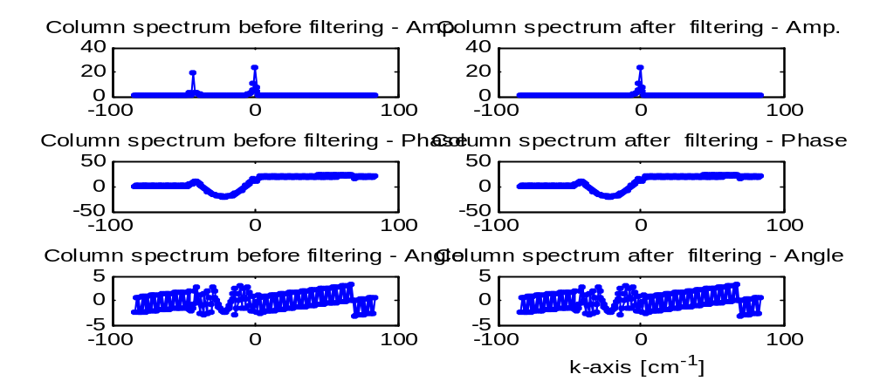
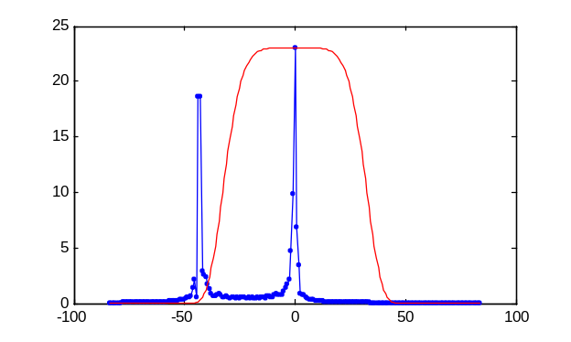
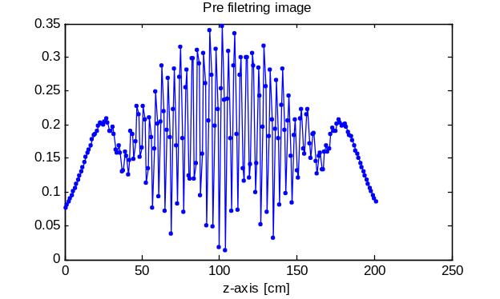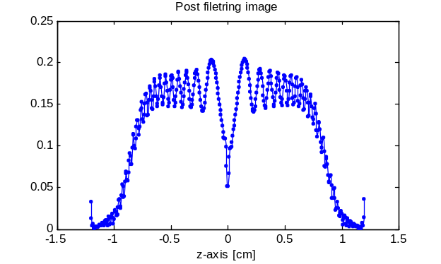

556.fid
- Decrease ‘np’ to 100
- Move filtered echo to edge of k-space
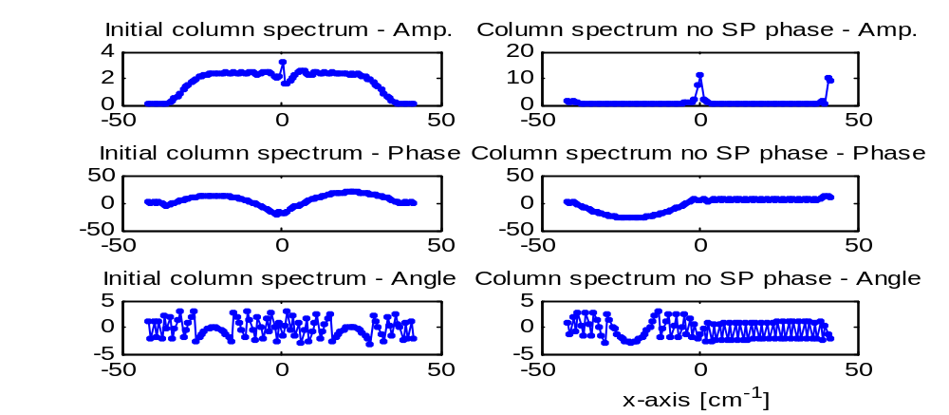
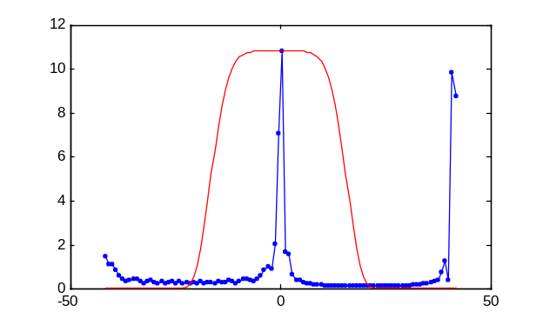
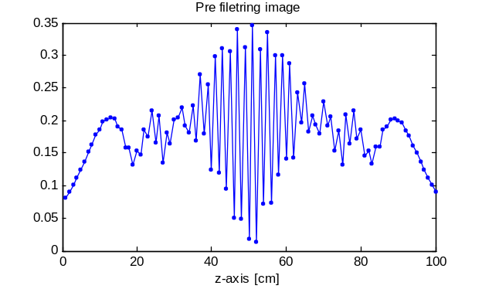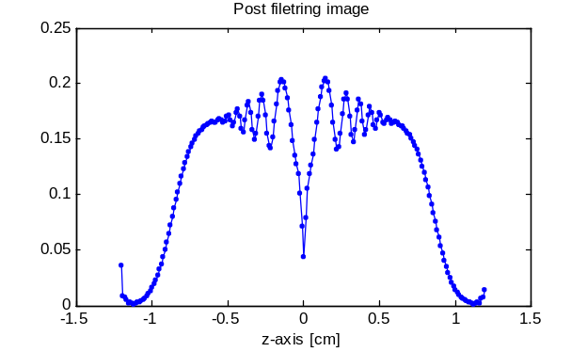
- Strong wiggles appear around the interface region – less than before due to decrease in ‘np’.

Best parameters image:
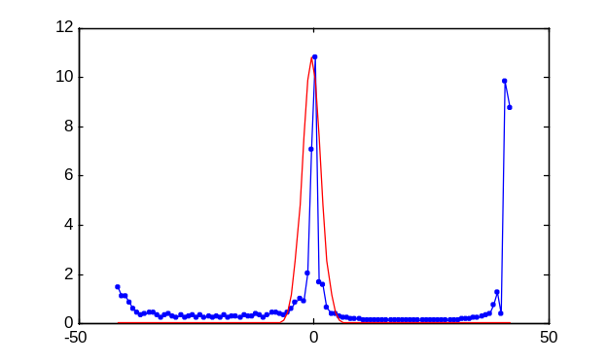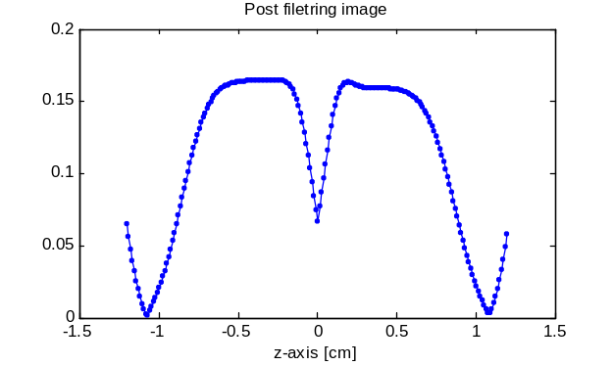
- This is a little pointless since along with the wiggles, went the image resolution.

Compare different window sizes:
ppWinExpVal = 20; ppWinESP = 6;
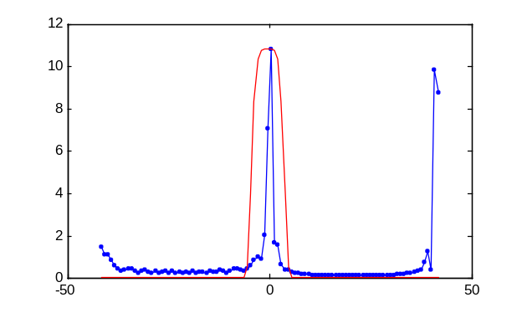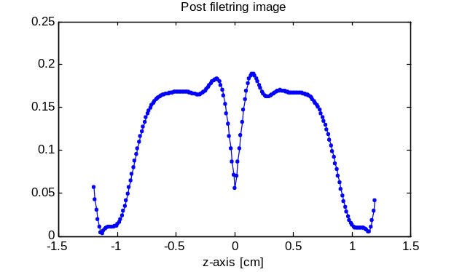
ppWinExpVal = 11; ppWinESP = 6;
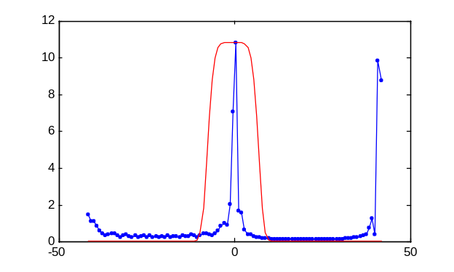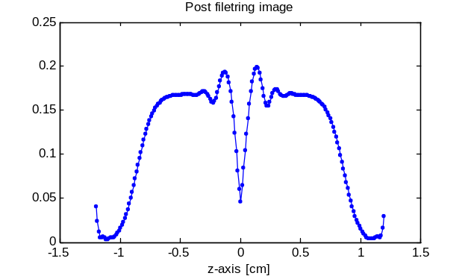
ppWinExpVal = 9; ppWinESP = 6;
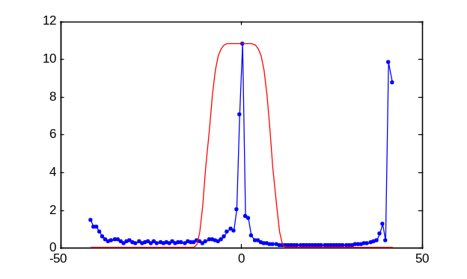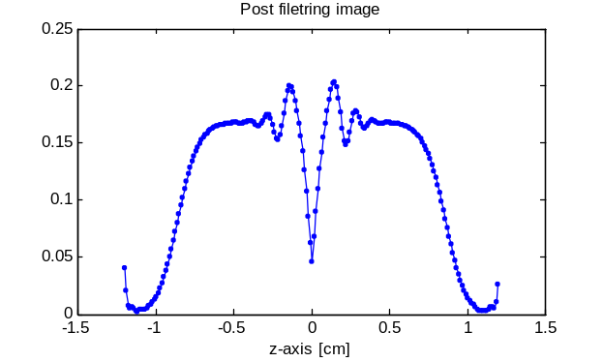
ppWinExpVal = 5; ppWinESP = 6;
ppWinExpVal = 3; ppWinESP = 6;

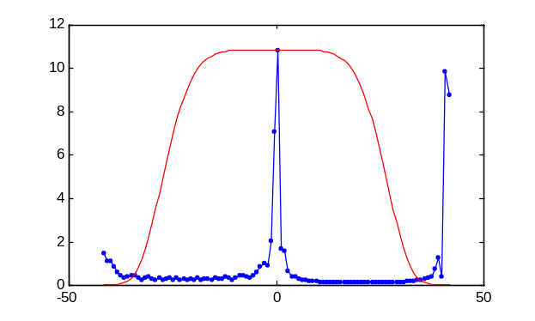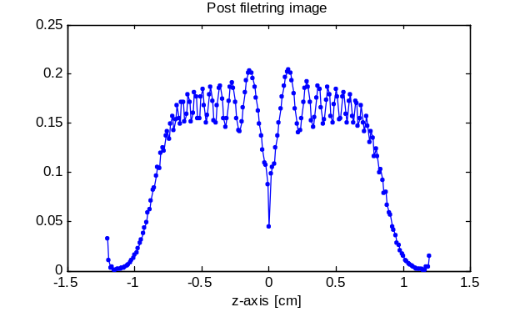
Compare different window ESPs:
ppWinExpVal = 11; ppWinESP = 3;
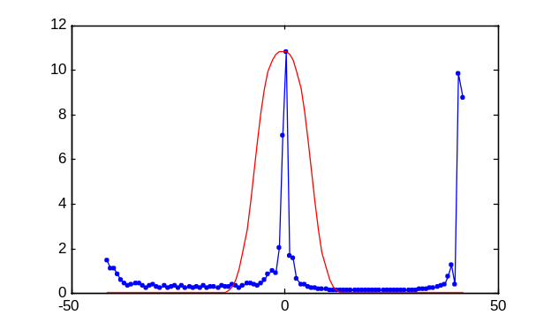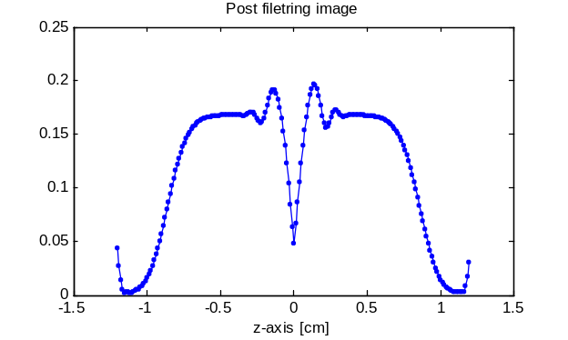
ppWinExpVal = 11; ppWinESP = 6;
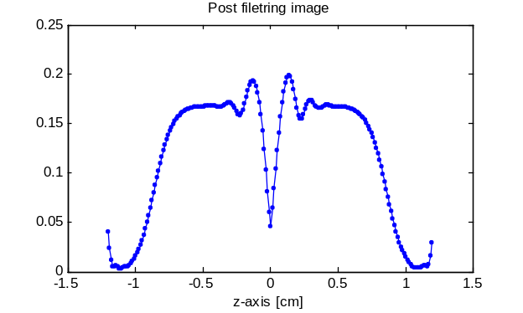
ppWinExpVal = 11; ppWinESP = 10;
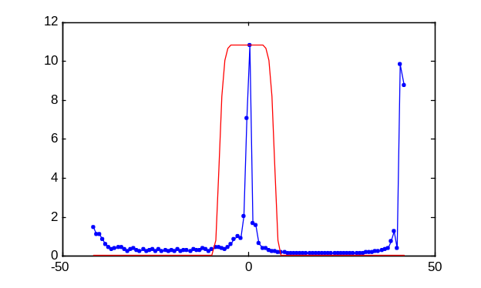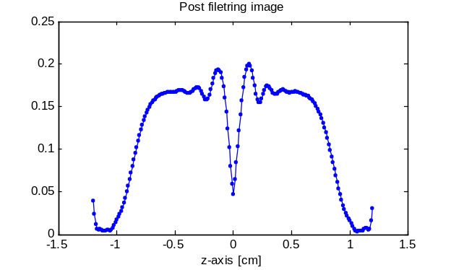
ppWinExpVal = 11; ppWinESP = 20;
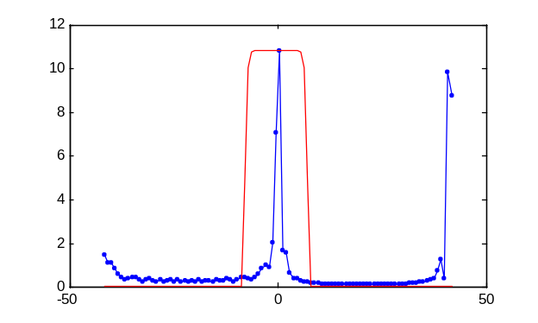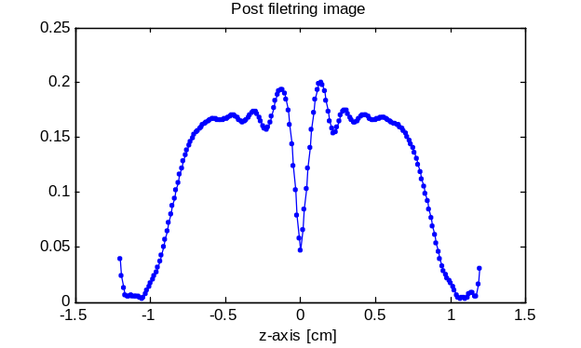
ppWinExpVal = 11; ppWinESP = 32;

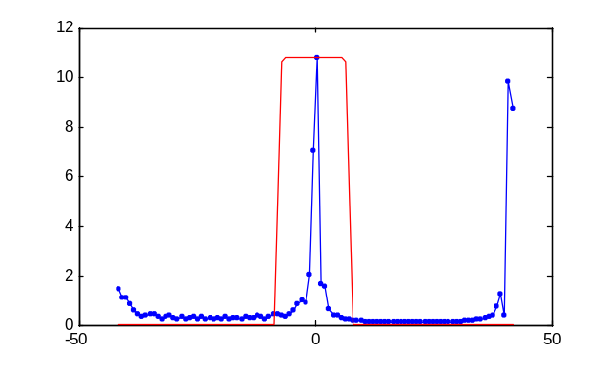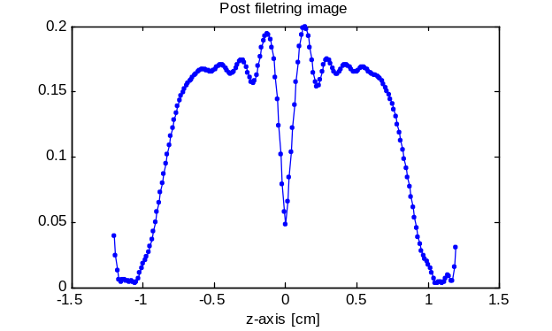

557.fid
Decrease ‘np’ to 50
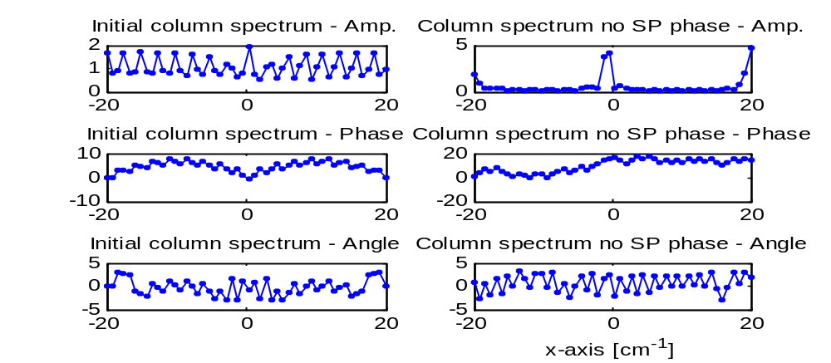
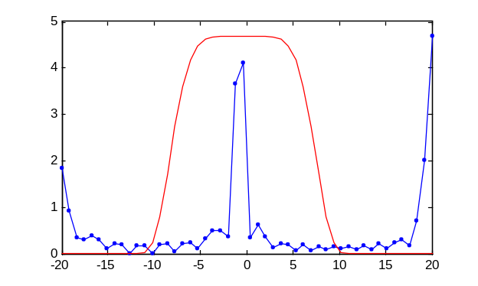
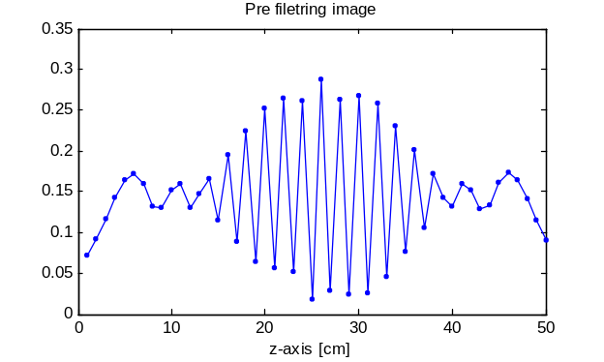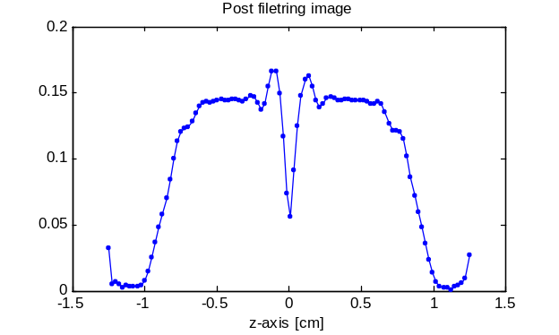

- Wiggles begin to disappear
- Image is less smooth

559.fid
- Decrease ‘np’ to 40
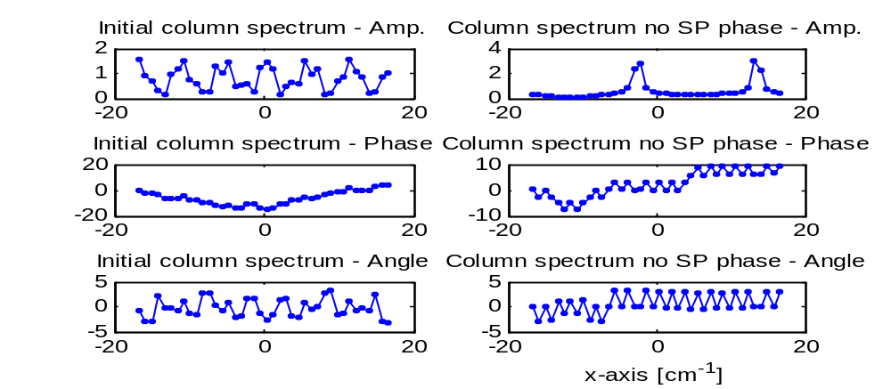
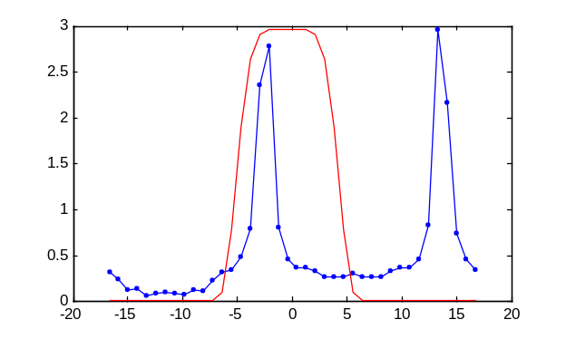
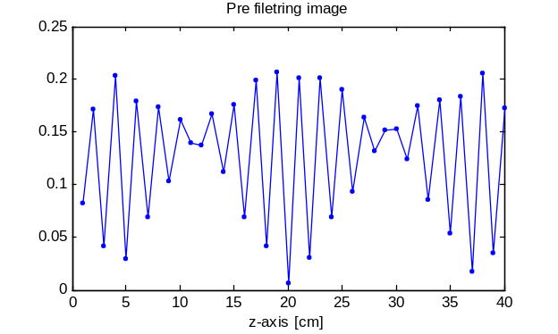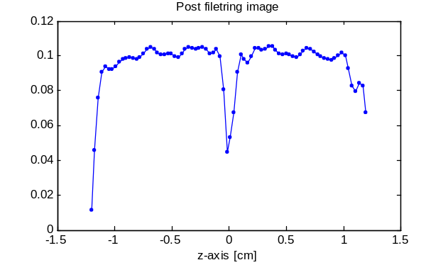

- Wiggles practically disappear but,
- Image is much less smooth

560.fid – Test the effect of the pixel size on the image
- np = 100
- Ge = 7.35 [G/cm]
- Tp = 8.00 [ms]
- dta = 40 [us]
- R = 9.39 [kHz/ms]
- Pixel size = 0.979 [mm]
- Sample sz = 2673 [pts]
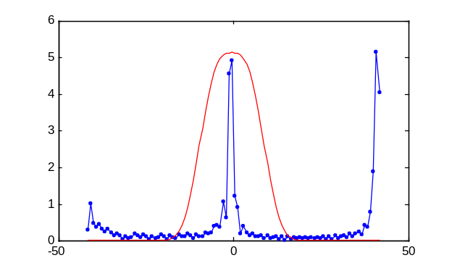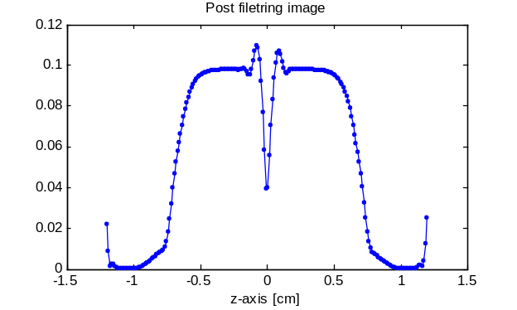

561.fid – decrease pixel size
- np = 100
- Ge = 8.15 [G/cm]
- Tp = 12.00 [ms]
- dta = 60 [us]
- R = 6.94 [kHz/ms]
- Pixel size = 0.759 [mm]
- Sample sz = 2673 [pts]
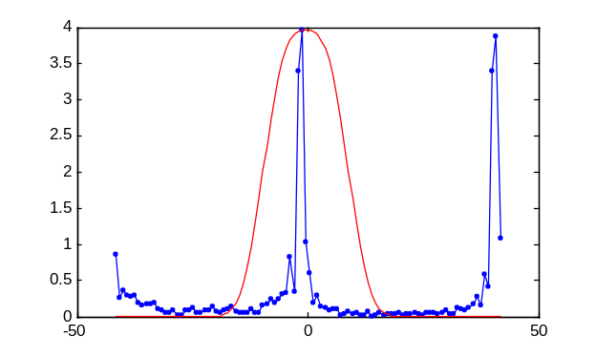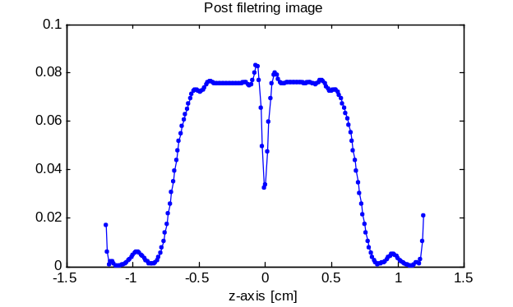

562.fid – test effect of ‘np’ on sample w/o signal at interface region
- np = 100
- Ge = 6.78 [G/cm]
- Tp = 8.00 [ms]
- dta = 40 [us]
- R = 9.38 [kHz/ms]
- Pixel size = 1.06 [mm]
- Sample sz = 2673 [pts]

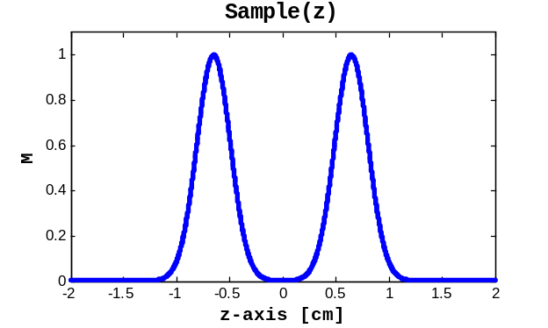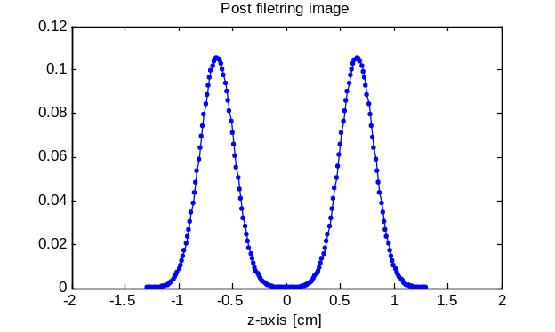

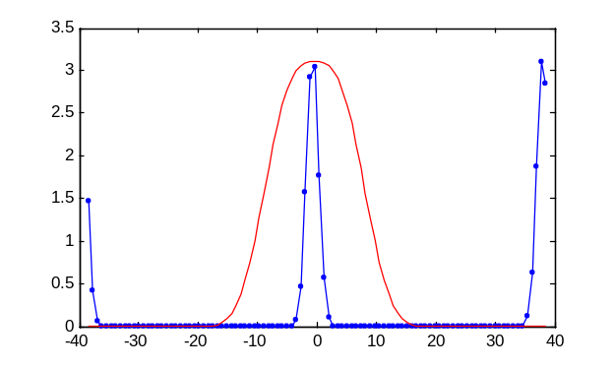

563.fid
- np = 307
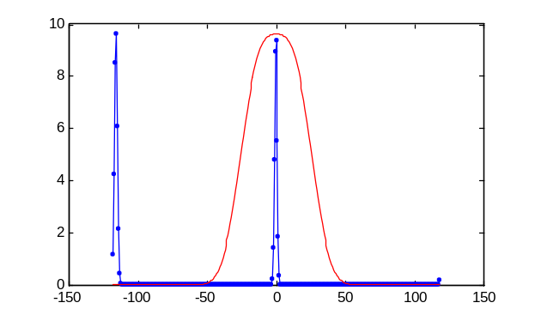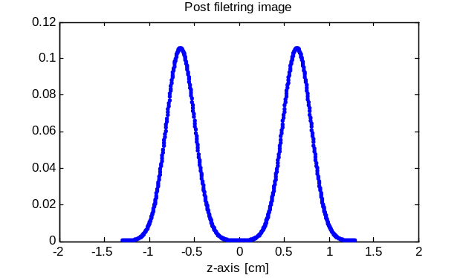
Conclusions:
- No change in the image (except the increase in number of points) when increasing ‘np’.
- No wiggles appear.
- No wiggles appeared even when increasing the widow size to twice the size shown above.

573.fid – Test decreased excitation around discontinuity region
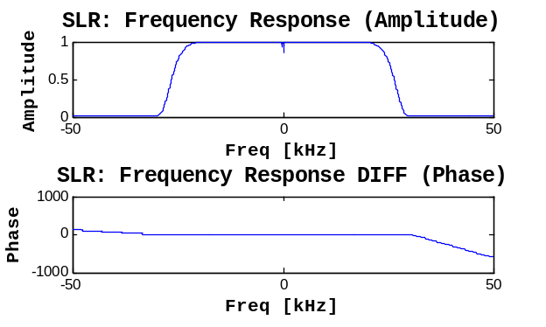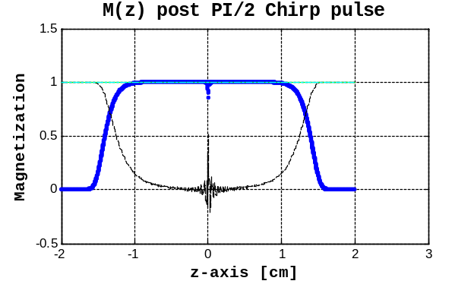
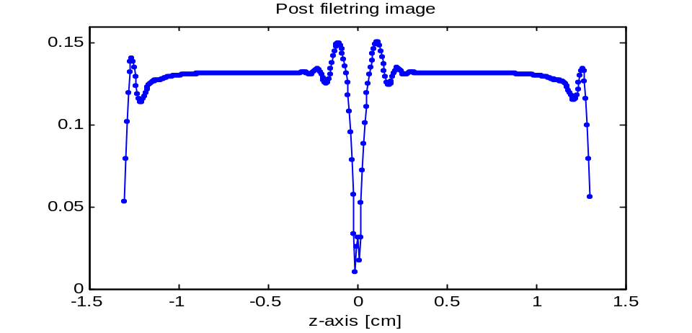

574.fid – sample = ones; w/ decreased excitation around discontinuity region
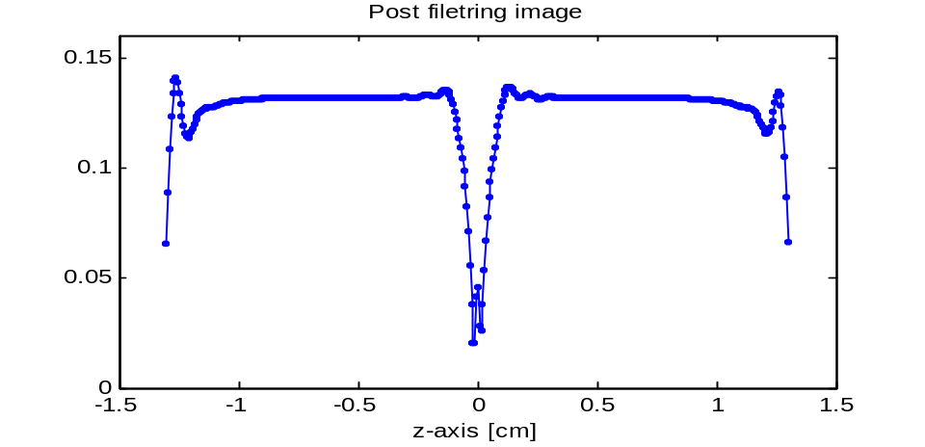
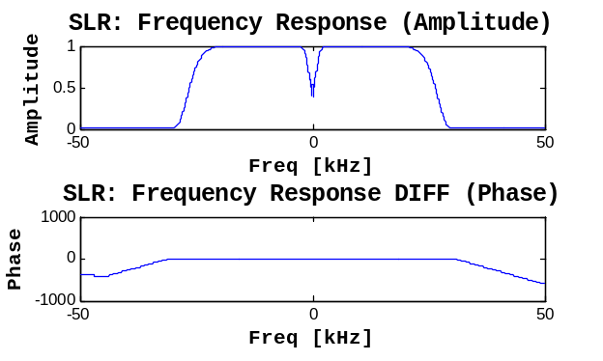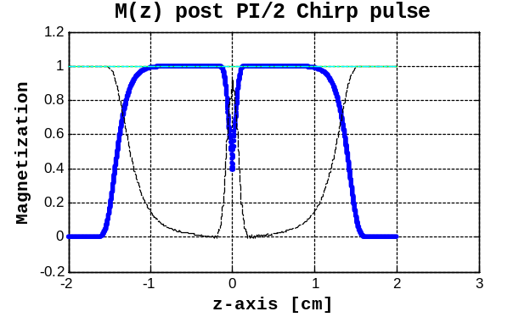
- Less signal → less wiggles

575.fid – sample = Gaussian

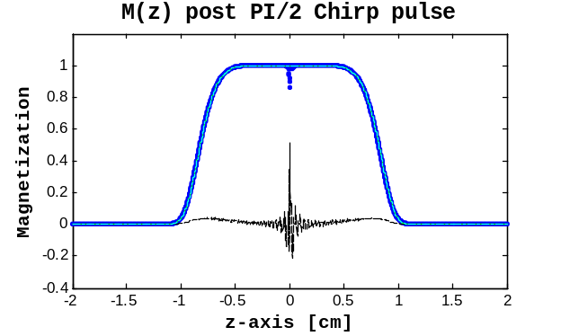
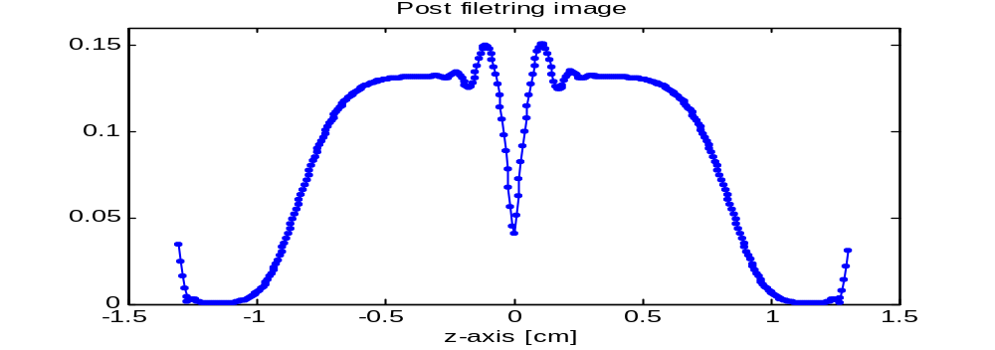

576.fid – sample = Gaussian; Decreased excitation around discontinuity region
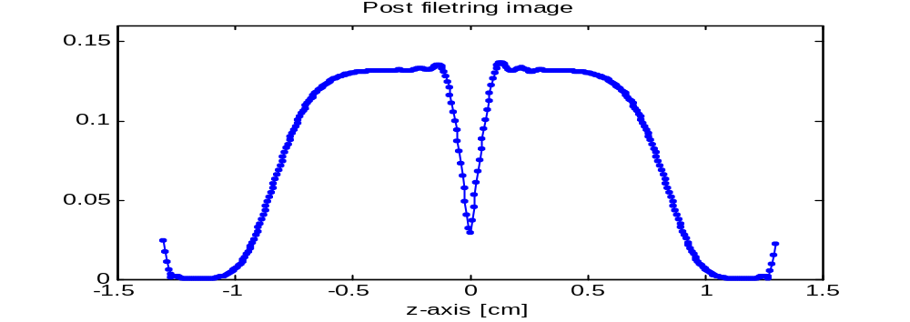
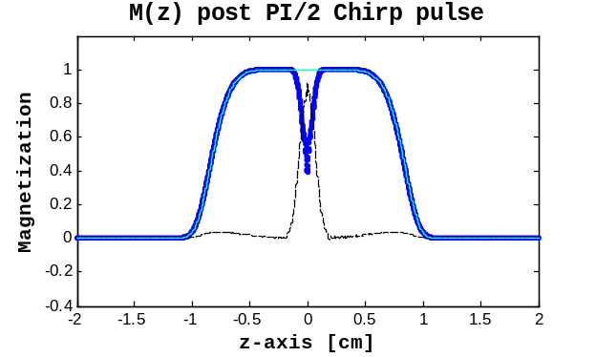
- As before: less signal → less wiggles

577.fid – Test pixel size and ‘np’
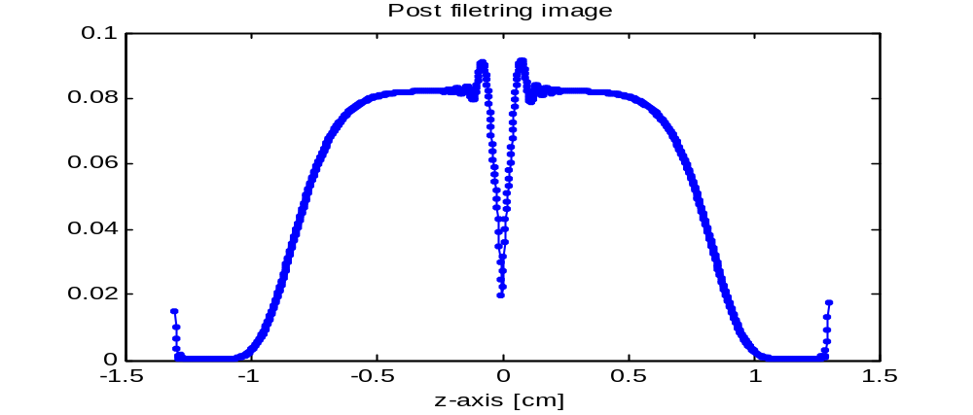dZa=0.822

578.fid
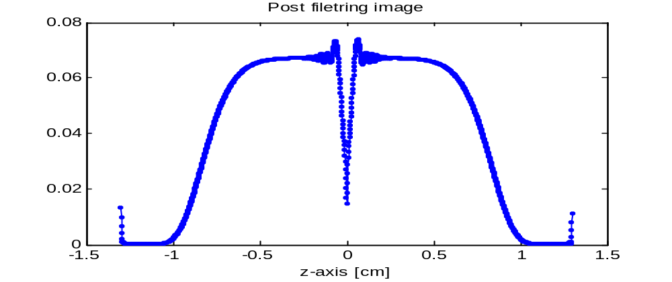dZa=0.671

579.fid – decrease # of acq points times 5 (750 → 150)
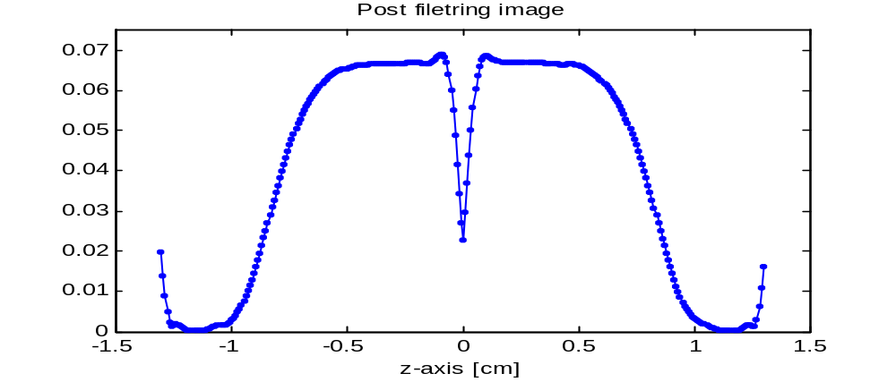dZa=0.671

